Assignment No.: 2

Course: PROG23199

Name: Prajwal Nautiyal

Sheridan Student Number: 991662442

Instructor's name: Syed Tanbeer

Requirement 1:

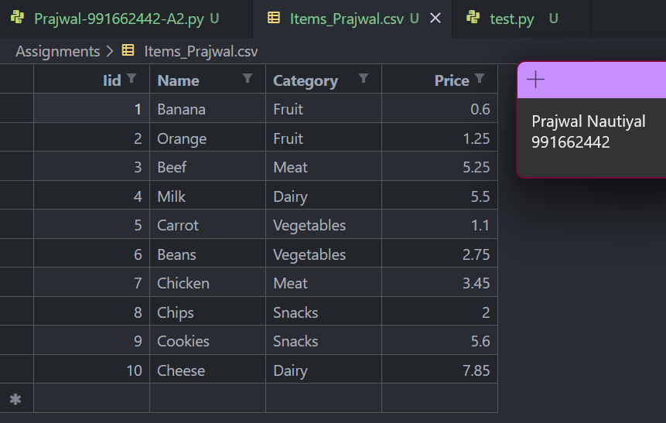

Requirement 2:

Items_Prajwal

Transactions

Requirement 3:

Requirement 4:

Requirement 5:

Requirement 6:

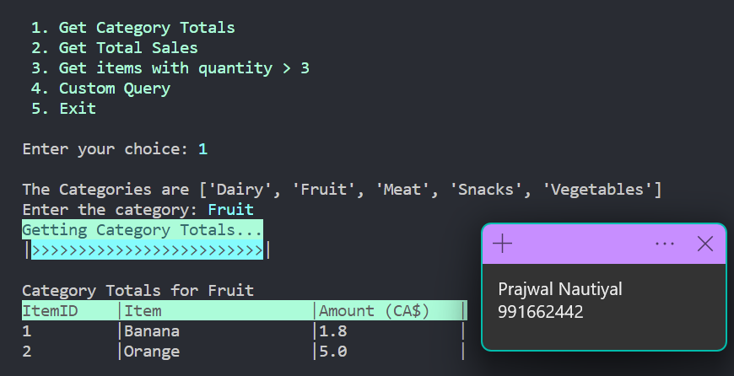

Requirement 7:

Requirement 8:

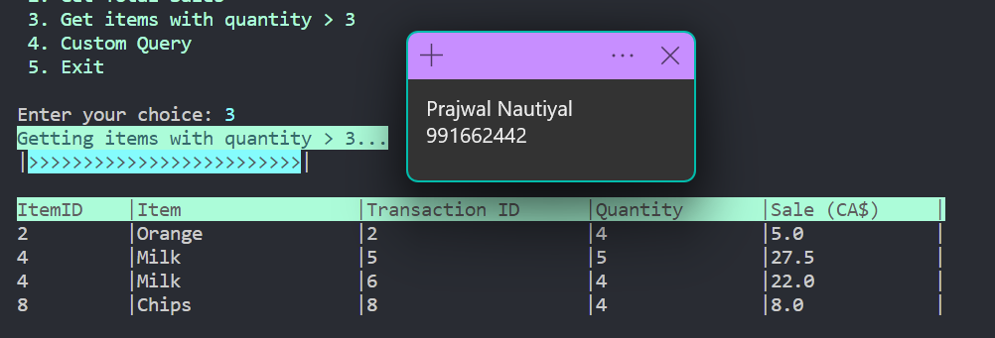

Requirement 9:

Requirement 10: